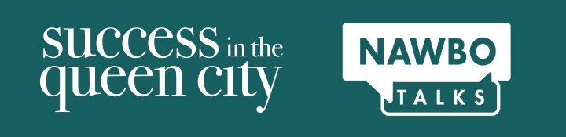

Do you have something meaningful to share?

Dear NAWBO Member,

Our annual Success in the Queen City event will be held in the evening on Tuesday, October 26, 2021. The focus is to bring together the numerous Businesswomen Organizations in Charlotte for an evening of connections, knowledge sharing, and celebration of Woman Business Owners.

Along with Success in the Queen City, we are thrilled to bring back NAWBO Talks. NAWBO Talks will be a speaking event similar in style to a Ted Talk. The speakers will cover a variety of topics, and the speeches will be 6-8 minutes each.

What is most exciting about this event is that our speakers will all be NAWBO Members! NAWBO Talks will showcase hand selected NAWBO Charlotte members speaking about topics that are meaningful to Charlotte women business owners.

The theme for NAWBO Talks is "Resilience in the Face of Change." The Ted Talk style speeches are designed to inspire, inform and evoke new ideas, as opposed to pitching a service or product.

Do you have a new way of approaching an old problem, a challenge to the status quo, or some fascinating research that impacts the businesswomen of Charlotte? Perfect! That's what we're looking for.

All NAWBO Charlotte members, who are current in their membership, are invited to fill out the Speaker Application. Keep reading for more details on applying.

Application Process – 2 Steps: Application and Video Deadline is October 8, 2021 by 5:00pm.

- Complete the application in full. You can find the application here.
- Submit 1–3-minute video of you presenting at an event, a podcast, website video, tutorial. YouTube, etc.

Announcement of Speakers: Tuesday, October 13, 2021

Selected presenters will receive further detailed instructions upon their acceptance.

There will be a selection committee that includes representatives from our business community.

We are very excited to provide this opportunity to the members of NAWBO Charlotte. We know that there is so much talent in our Queen City and we look forward to both providing the forum for that talent and providing excellent value to our membership.

If you’d like to apply, please complete the form here.

Please be on the lookout for more details on the event coming soon!

